Software Requirement Specifications
An AI-Powered Web Application for Skin Cancer Detection
and Cure Recommendation



Submitted by
Abdul Rehman (F22BINFT1M01133)
Submitted to
Dr. Syed Ali Nawaz Shah

Department of Information Technology
Faculty of Computing
The Islamia University of Bahawalpur

Meeting Details
Sr No | Details | Date | Supervisor Signature
1 |  | 5 November
  Initial Proposal Discussion
2 |  | 5 December
  SRS Review

Summary
This document specifies the Software Requirements for the Skin Cancer Detection Model, a project designed to assist dermatologists and medical researchers in the early detection of skin cancer. The system uses advanced AI techniques, specifically a Convolutional Neural Network (CNN), to analyze images of skin lesions and classify them as benign or malignant.
The SRS details the functional requirements, including image upload, preprocessing, classification, and result display, as well as optional user account management. Non-functional requirements such as performance, accuracy, security, reliability, and usability are also outlined to ensure the system meets professional and medical standards.
Additionally, the document provides an overview of similar systems and research in the domain, identifies the proposed technologies including Python, TensorFlow, Keras, and relevant datasets (ISIC, HAM10000), and presents use case descriptions and flow of processes to guide system development. This SRS serves as a complete reference for developers, supervisors, and stakeholders to understand the project objectives, scope, and implementation plan.

Table of Contents
1. Introduction 4
1.1. Purpose 4
1.2. Scope 4
1.3. Product Perspective 4
1.4. User Characteristics 4
1.5. Similar apps and systems/Literature Review 4
1.6. Proposed Technologies 4
2. Requirements 5
2.1. Function Requirements 5
2.1.1. Sign Up 5
2.2. Non-Functional Requirements 5
3. Use Cases and Flow of Processes 6
3.1. Use Case 1 7
4. References 8

- Introduction

Skin cancer is one of the most common types of cancer worldwide. Early detection is critical for effective treatment. AI-based systems can assist dermatologists in analyzing skin lesions by automatically classifying images as benign or malignant.
  - Purpose

The purpose of this project is to develop a user-friendly AI-based skin cancer detection system that:
- Processes and classifies skin lesion images.
- Provides confidence scores for predictions.
- Assists dermatologists and medical researchers in early diagnosis.
  - Scope
- Included Features:
  - Image upload and validation
  - Image preprocessing
  - CNN-based classification
  - Display of result with confidence score
- Excluded Features:
  - Replacement of professional medical diagnosis
  - Treatment suggestions or medical prescriptions
  - Product Perspective

The system will be developed as a standalone software/web application. In the future, it can potentially integrate with hospital management systems to provide real-time support for dermatologists.

  - User Characteristics
- Primary Users: Dermatologists, medical students, researchers
- Skills Required: Basic computer literacy, ability to upload images
- Experience Level: No prior AI knowledge required
  - Similar apps and systems/Literature Review
- Research papers have implemented CNN-based skin lesion classification models achieving 85–95% accuracy.
- Existing apps mostly focus on mobile platforms with limited dataset sizes.
- Shortcomings: lack of explainability, limited confidence scoring, dependency on high-quality images.
  - Proposed Technologies
- Programming Language: Python
- Libraries: TensorFlow, Keras, OpenCV, Flask (for GUI)
- Hardware Requirements: GPU recommended for training CNN
- Datasets: ISIC, HAM10000
- Requirements
Authors have to provide a brief of functions of the project. For example, if a Hospital Management System is going to develop and Patient and Doctor module is going to implement then patient admission, appointment system and billing can be described here. Authors will write these items in the form of paragraph without providing some title.
  - Function Requirements
- The Skin Cancer Detection System will provide a user registration feature that allows new users to create an account by entering their name, email address, and password. The system will validate all input fields and ensure that the password meets minimum security requirements. After successful registration, users will be able to log into the system using their credentials.
- Once logged in, the user will be able to upload skin lesion images in supported formats such as JPG and PNG. The system will validate the uploaded image to ensure it is in the correct format and not corrupted. If the image is invalid, the system will display an appropriate error message.
- After successful image upload, the system will automatically perform image preprocessing, including resizing, normalization, and noise reduction, to make the image suitable for analysis. The processed image will then be passed to the trained Convolutional Neural Network (CNN) model.
- The CNN model will classify the skin lesion as either benign or malignant. The system will generate a prediction result along with a confidence score, which will be displayed to the user in a clear and understandable format.
- The system will also allow users to view their previous prediction results if the history feature is enabled. In case of any system error, invalid image, or processing failure, the system will provide proper error handling and feedback messages to guide the user.

  - Non-Functional Requirements
- Performance: Prediction within 5 seconds
- Accuracy: ≥85%
- Reliability: 99% system uptime
- Security: No sensitive data stored
- Usability: Simple GUI for ease of use

- Use Cases and Flow of Processes
- Name | Image Upload & Classification

- Description | Process flow for uploading skin lesion image and classifying it

- Requirement(s) | FR001, FR002, FR003, FR004

- Actor(s) | Dermatologist, Researcher

- Precondition | User logged in (if applicable)

- Postcondition | Result displayed with confidence score

- Basic Flow | 1. User uploads image  2. System validates image format  3. System preprocesses image  4. CNN model predicts lesion type  5. Result displayed on GUI

- Alternative Flow | Invalid image → display error message

- Exceptions | Corrupted file, system error

Diagram
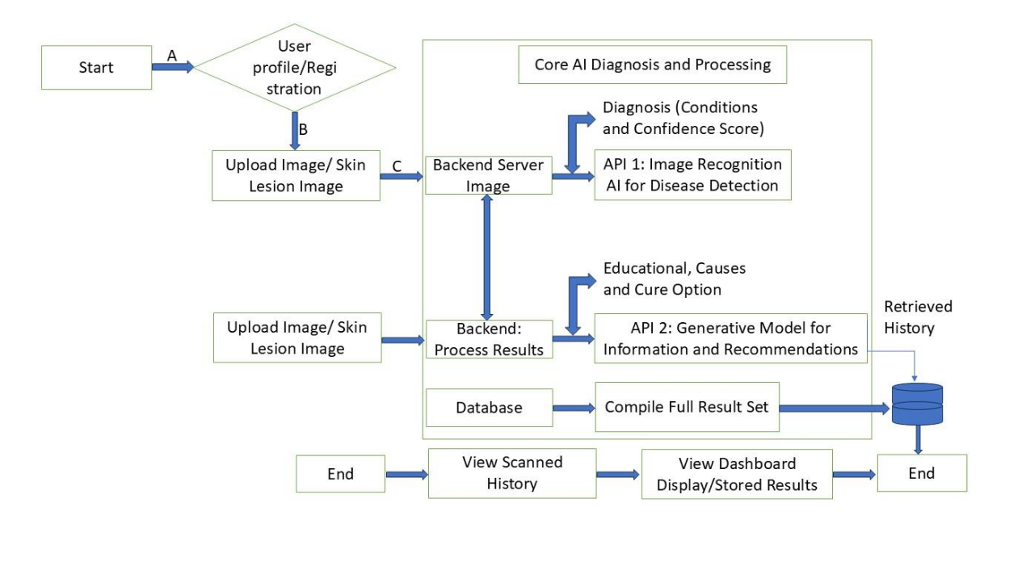

- References
- [1] N. C. Codella, D. Gutman, M. E. Celebi, et al., “Skin lesion analysis toward melanoma detection: A challenge at the 2017 International Symposium on Biomedical Imaging (ISBI),” IEEE Transactions on Medical Imaging, vol. 37, no. 2, pp. 554–568, Feb. 2018.
- [2] P. Tschandl, C. Rosendahl, and H. Kittler, “The HAM10000 dataset: A large collection of multi-source dermatoscopic images of common pigmented skin lesions,” Scientific Data, vol. 5, no. 180161, 2018.
- [3] International Skin Imaging Collaboration (ISIC), “ISIC Archive,” 2020. [Online]. Available: https://www.isic-archive.com
- [4] TensorFlow Development Team, “TensorFlow: Large-scale machine learning on heterogeneous systems,” 2015. [Online]. Available: https://www.tensorflow.org
- [5] F. Chollet, “Keras: Deep learning for humans,” 2015. [Online]. Available: https://keras.io

